Modeling Biofuel Expansion Effects on Land Use Change Dynamics

Authors: Ethan Warner1[1] , Daniel Inman2, Benjamin Kunstman1, Brian Bush1, Laura Vimmerstedt1, Steve Peterson3. 4. 5, Jordan Macknick1, Yimin Zhang1

1 Strategic Energy Analysis Center, National Renewable Energy Laboratory, 15013 Denver West Parkway, Golden, CO, USA

2 The National Bioenergy Center, National Renewable Energy Laboratory, 15013 Denver West Parkway, Golden, CO, USA

3 Peterson Group, Lebanon, NH, USA

4 Lexidyne LLC, Colorado Springs, Colorado, USA

5 Thayer School of Engineering, Dartmouth College, Hanover, New Hampshire, USA

a Corresponding author: [Ethan.Warner@nrel.gov](mailto:Ethan.Warner@nrel.gov)

**Abstract**

Biofuel feedstock production, in addition to other human drivers of land use, can induce direct and indirect land use changes (LUC). However, the dynamics ofexisting LUC dalong with their assumptions are difficult to test with existing tools. We describe a system dynamics (SD) global LUC model intended to examine LUC attributed to biofuel production. We discuss major global land system stocks and flows and present model results under different food and biofuel demand assumptions. Although it is not intended to give(or “generate”) precise numerical predictions, this model provides insights into the drivers and dynamic interactions of LUC, population, dietary choices, and biofuel policy.Commodity demands are met in high food and high biofuel demand scenarios, but cropland must expand substantially. Meeting roughly 25% of global transportation fuel demand by 2050 with biofuels would use under 700 million hectares of land for biomass growth, higher than the 300 million hectares for biomass in the high food demand scenario that presumes almost a 40% increase in per-capita demand from business as usual (BAU). In comparison, the high food demand scenario requires greater pastureland for meat production, leading to larger overall expansion into forest and grassland. Our results indicate that, in all scenarios, there is potential for a supply shortfall, and associated upward pressure on prices, of higher-land-intensity food commodities (e.g., beef) which biofuels could exacerbate.

1. **Introduction**

Initial biofuel assessments (e.g., Farrell *et al* 2006) suggested that biofuels, such as ethanol, could help the United States (US) reduce greenhouse gas (GHG) emissions. However, Searchinger *et al* (2007) and Fargione *et al* (2007) highlighted that previous biofuel studies failed to include the effects of global land use change (LUC). These two watershed studies modeled the potential impact of carbon released from soils and above-ground biomass during land clearing activities triggered by increased demand for biofuel. Results from these studies, as well as many other biofuel-induced LUC studies, hinge on assumptions regarding direct and indirect causal relationships (see Supplemental Information [SI Section 1 for more detail) between drivers of LUC, land availability, biomass yields, population dynamics, dietary choices, relative affluence, and biofuel demand, to name a few. However, the causal relationships that underpin such results are not completely understood and there remains significant disagreement on many fundamental aspects of LUC dynamics. LUC in general, as well as those changes attributable to biofuels, has far-reaching implications for many aspects of sustainability i.e.,biodiversity and societal impacts (e.g., food security). For example, diversion of land to biofuel crops displaces production that may lead to compensating production of substitute crops elsewhere, affecting regional food crop prices (Chum *et al* 2011, Dale *et al* 2011).Therefore, a better understanding of the drivers of LUC and high-level influences on system behavior is critical to the responsible and sustainable development of biofuels..

Inclusion of LUC impacts in renewable fuels policy is contentious, because it is neither directly measurable nor easily isolated from the myriad of other LUC drivers (Plevin *et al* 2010), such as agricultural policies, agricultural product demand changes, and social norms. Biofuel policy analyses typically rely on computer simulations or on extrapolations of historic data to evaluate total LUC. The LUC modeling science lacks consensus with regard to modeling frameworks, boundary conditions, and other fundamental assumptions, which has resulted in highly variable modeling results across a wide range of studies. For example, results of CO2 emissions from biofuel-induced LUC span an order of magnitude, and subsequent calculations of GHG emissions can even vary in sign (Berndes *et al* 2010). Currently, US and European governmental organizations are integrating-- or are considering integrating--LUC impacts into their renewable fuel policies (e.g., the US Renewable Fuel Standard (RFS) (US Environmental Protection Agency (EPA) 2010), EU Renewable Energy and Fuel Quality Directive (European Commission 2009), United Kingdom (UK) Renewable Transport Fuel Obligation (UK Department for Transport 2012), and California’s Low Carbon Fuel Standard (CARB 2009). At present, analysts most often use agricultural economic models such as variations of the Global Trade Analysis Project (GTAP) model. For example, the US EPA uses the GTAP along with the FAPRI model (US EPA 2010, Tyner *et al* 2010, Al-Riffai *et al* 2010).

The modeling approach presented in this study is intended to complement existing approaches and to improve the understanding of global LUC drivers and dynamics. Every effort has been made to ensure the model is parsimonious and transparent, both in terms of the underlying data and the feedback effects among drivers. By using a model with high transparency, ease of use, and dynamic capabilities, our project improves policy-relevant analyses by allowing examination of global LUC under diverse scenarios and varying model assumptions. In this paper, we report on a small subset of such analyses. These are intended as an initial illustration of model functionality, not to assert improvement in numerical results relative to other work.

**LUC Models and Approaches**

Based on our review of the literature, we categorize most biofuel-related LUC modeling approaches into three broad categories: (1) general and partial economic equilibrium modeling, (2) simple deterministic methods, and (3) causal descriptive methods. Each method has strengths and weakness in modeling LUC and its causes (see table 1), because purposes of models vary. Modeling classifications listed in Table 1 suggest a spectrum of complexity, with higher quantitative requirements on the left side.

**Table 1**. Comparison of models using different methods used to estimate LUC in existing literature (Ackerman 2002, ICF International 2009). The system dynamics (SD) description is limited to our own modeling framework.

|  |  |  |  |  |
| --- | --- | --- | --- | --- |
|  | **General and Partial Economic Equilibrium Models** | **System Dynamics** | **Causal descriptive method** | **Deterministic method (simplified)** |
| **Description** | Calculates LUC resulting from the cause-and-effect relationships in a market system measured based on the change resulting from shocking an economic system at equilibrium with an expansion of biofuels. Uses historic trends and for calibration. | Calculates LUC using cause-and-effect relationships in a dynamic stock-and-flow framework to assess market responses resulting from increasing demand for biofuels. Uses historic trends as inputs and for calibrating cause-and-effect relationships | Calculates LUC using cause-and-effect relationships to assess market responses resulting from increasing demand for biofuels. Uses historic trends as inputs and for calibrating cause and effect relationships | Generates an "average" adder for agricultural products considered relevant to the bioenergy sector based on historic land use data. Direct and indirect LUC are sometimes combined but sometimes separate factors. |
| **Potentially limiting assumptions in existing models** | **1)** A unique set of commodity prices exist that will lead to an overall equilibrium (in a whole economy or in a single market).  **2)** LUC is driven by economic forces. | **1)** Future market responses (e.g., product substitution, cultivation area of a given crop) to increased demand for biofuels can be extrapolated from historical trends and relationships between economic, agricultural, and social systems.  **2)** Market responses are driven by relatively independent external assumptions, but internal moderating feedbacks are included. | **1)** Future market responses (e.g., product substitution, cultivation area of a given crop) to increased demand for biofuels can be extrapolated from statistical analysis of historical trends.  **2)** Different market responses are relatively independent and can be quantified without considering possible correlations. | **1)** Countries trading agricultural commodities might be subject to LUC effects  **2)** The patterns of global trade of agricultural commodities will remain virtually unchanged in the near future, and therefore the incremental effect of biofuel expansion on land use will always have the same global impact.  **3)** LUC caused by increased biofuel feedstock production can be directly estimated from the type and share of land used to grow agricultural commodities for export purpose. |
| **Strengths** | **1)** Captures, in detail, many important market and economic factors that can drive LUC  **2)** Usually based at institution that offers technical support | **1)** Can relatively easily incorporate important LUC drivers other than market and economic factors.  **2)** Can be transparent and involve stakeholders in scenario development. | **1)** Can relatively easily incorporate important LUC drivers other than market and economic factors  **2)** Can be transparent and involve stakeholders in scenario development. | **1)** Easy to calculate and transparent. |
| **Limitations** | **1)** Currently, usually fails to include other important LUC drivers (e.g., political, cultural, demographic, environmental forces) that may not rely on land and commodity prices and elasticities  **2)** Relatively low transparency. Often difficult to gain access to or use by non-experts economic modelers. | **1)** Misses dynamic and interlinked LUC driving factors in cause-and-effect chains because of reliance on historical data and relationships to identify LUC drivers.  **2)** Data and relationships operate at relatively aggregate low-resolution level. | **1)** Misses dynamic and interlinked LUC driving factors in cause-and-effect chains because of reliance on historical data and relationships to identify LUC drivers.  **2)** Data and relationships operate at relatively aggregate low-resolution level. | **1)** Generally does not consider land types not used for producing traded agricultural commodities.  **2)** Omits market feedbacks and policy measures that affect trade patterns  **3)** Data and relationships operate at a relatively very aggregate low-resolution level. |
| **Example papers** | Hiederer *et al* 2010, Al-Riffai *et al* 2010, US EPA 2010, Tyner *et al* 2010, Wise *et al* 2009 | Sheehan 2009 | Bauen *et al* 2010, Lywood 2008 | Kim *et al.* 2009, Fritsche *et al.* 2010, Tipper *et al* 2009 |

The new model, called BioLUC, is a SD simulation model (NREL 2012, Bush *et al* 2011) that represents key economic and social drivers of global LUC and their interactions over time, enabling exploration of different scenarios with implications for LUC.[2] In particular, BioLUC can explore implications of and assumptions about LUC by analyzing the limits of sustainable biofuels production under varied future conditions regarding inputs, specifically population growth, crop yields, and plant and animal product supply and demand. BioLUC was created using the STELLA Version 9.1.4 software package (ISEE Systems, Lebanon, New Hampshire) using a stock-and-flow structure; it focuses on information feedback processes that underwrite the dynamic movement of key quantities over time.

BioLUC generally would fit the causal descriptive category. However, to date, causal descriptive modeling systems have been spreadsheet-based models that lack dynamic stock-and-flow frameworks. To explain the distinctions we describe SD models in a separate column in Table 1. See SI Section 2 for additional details about SD modeling, its historical context, and its use in projecting the consequences of today’s and potential future policies.

The BioLUC model recognizes the accomplishments of past LUC modeling efforts and provides a modeling option that may address some of the limitations of current methods evaluating LUC. Transparency and ease-of-use are challenging to achieve when examining issues of biofuel-induced LUC, especially for the many interested stakeholders who are not economic modeling specialists. Enabling this community to access a transparent analytic method can help them work together to understand and analyze underlying LUC drivers; test assumptions about LUC systems against historic data; investigate future conditions; and assess implications of new LUC research results (Sheehan 2009, Sheehan 2012). As tools for this kind of shared exploration, existing models are either too complex, with light model structure documentation, difficult data access, or, alternatively, grossly simplistic (i.e., deterministic method). A SD modeling approach building on the causal descriptive method attempts to fill this analysis space.

The fundamental interactions, purported drivers, and impacts of LUC can readily be modeled using SD. Parsimonious SD models can be powerful tools for generating and communicating important insights to the public (Forrester 2007), and SD has long been used to examine and inform a wide variety of public policy questions and applications (Ghaffarzadegan *et al* 2011). Users can easily modify BioLUC to test the effects of policies or model assumptions. Another benefit is its capability for dynamic analysis: our model, crop yields and food demand profiles (e.g., meat demand and caloric preferences) may dynamically (and endogenously) change over time due to improvements in economic and technological wealth. This provides flexibility for assessing a range of plausible LUC impacts as part of sensitivity or Monte Carlo analysis at a high level, before carrying out a fuller analysis with a more detailed economic equilibrium model.

1. **BioLUC Modeling Approach**

The generalized influence diagram for a generic region of the world in the BioLUC model is presented in figure 1. The movement of land between usage categories over time is represented in the model using stocks for four different land bases, which flows into or out of those stocks. Within the “Crops” land base, land is allocated among multiple competing uses (e.g., food, feed, fuel, and fiber). Note the “Abandoned” category among the land bases: this land category, assumed nonproductive, enables us to explore land abandonment and rehabilitation scenarios. “Available” land is forest and grassland that is potentially available for productive use as pasture or cropland.

Figure 1 also shows how externally-defined scenarios for key parameters impact the system: biomass yield and crop land allocation determine production of various crops; and population, per-capita demand, and biofuel demand drives “direct” demands for various crops.

BioLUC represents key feedback processes that drive the allocation of land over time. Examples of these processes include:

* Imbalances between production and consumption of various agricultural products motivate changes in the allocation of land among different uses at a regional level.
  + Demand for animal products creates additional demand for crops grown as feed.
  + Crop and animal product imbalances between production and consumption stimulate adaptive responses in the system to move towards equilibrium.
  + Re-allocation of existing crop land among different uses balances the mix of crops produced against the mix of crops required.
* Re-distribution of the land bases, for example by converting available land into pastureland or by turning pastureland into crop land, adjusts production to more closely meet demand.
* Crop or animal product imbalances are further reduced through imports/exports from other regions.

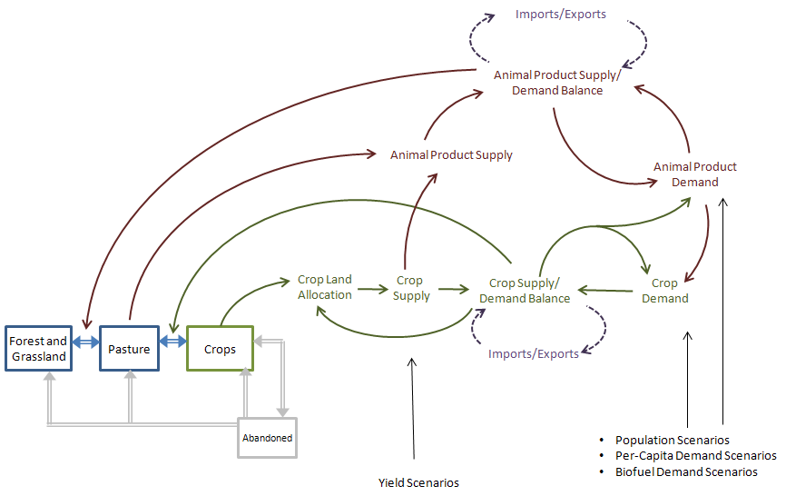

**Figure 1.** Illustrative influence diagram for each geographic region modeled,i.e. US and the rest of the world (ROW). Primary land stocks are represented by boxes, interactions are represented by connecting arrows, and inputs variables are represented by unboxed text.

The model is rich in feedback linkages, and an imbalance between demand and supply stimulates multiple feedback mechanisms. For example, holding other things equal, if the combination of population, per-capita demand, and biofuel scenarios cause consumption of a particular crop to exceed its production within a region several processes will begin to unfold:

* Regional inventories of the crop will begin to decline.
* The resulting supply shortfall will constrain consumption to levels lower than those implied by population, per-capita demand and biofuel scenarios.
* The supply shortfall will cause the region to call for imports from outside the region.
* Additionally, the supply shortfall will lead to a reallocation of crop land in favor of the crop in question.
* Reallocation of cropland will increase the rate or pressure to move land either from pasture into crops, which in turn will increase pressure to convert land from available into pasture

As these processes play out over time, the system will seek to balance itself so that equilibrium between supply and demand for crops within a region is restored.

We initially developed a two-region version of the model that can be used to represent any two regions. In this paper, these two regions represent the US and the ROW, but with different input data, the model can instead represent any other two-region division of the global economy, developed and developing regions, for example. We also have developed a flexible regional structure that can accommodate expansion to multiple regions. The model logic that controls imports and exports is shown, for two regions, in figure 2..

Modeling intra-region imports and exports is crucial to assessing LUC effects, and was a particularly challenging aspect of BioLUC construction. In reality, such movements can be highly complex, and are driven by economic, political, and social considerations. We model cross-region movements of commodity crops and animal products as equilibrium-seeking, but with specific constraints: within any region, a supply/demand imbalance increases imports or exports, but globally, total imports must match total exports. The geographic regional structure of the model determines the boundaries across which imports and exports occur. The finer details of trade relationships, such as willingness to pay, are not modeled but are implicitly captured.

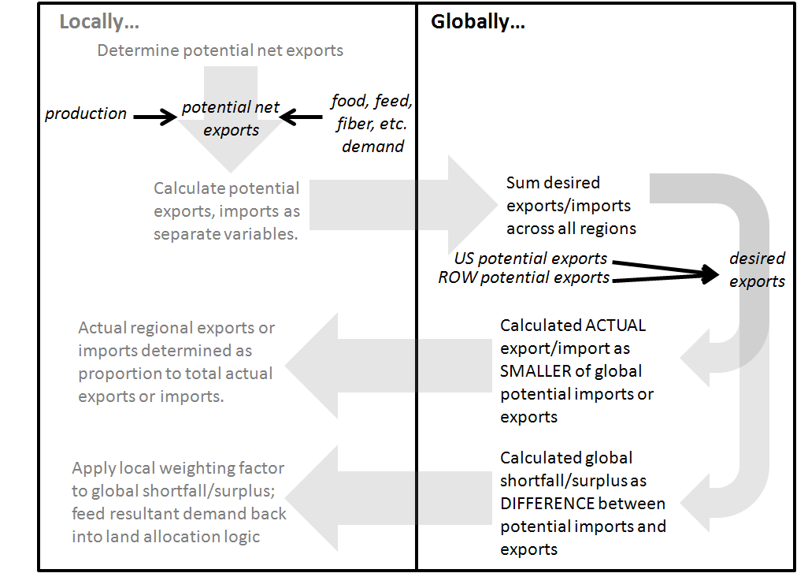

**Figure 2.** Import and export modeling in BioLUC.

Food and Agricultural Organization Statistics (FAOSTAT) (2010) is the main land cover dataset used in BioLUC, as it is one of the few global land cover and agricultural commodity datasets covering a long period of time. The FAO dataset is freely available and generally transparent, but it suffers from low spatial resolution. The low spatial resolution of this dataset, combined with the low regional resolution of BioLUC, means that the model does not differentiate productivity of different land parcels. In other words, this is not a geographically dynamic model. Another limitation is that FAOSTAT (2010) also includes protected lands within its accounting framework making such land available in theory for use in our model.

For additional details about model structure and input assumptions, across all scenarios included agricultural commodity yields, changes in population, and initial land cover at the start of the model, see data and model calculations in Section 3 of the SI

1. **BioLUC Model Scenarios**

We explore four scenarios to broadly examine the effects of demand for biofuels and food on LUC as outlined below and in table 2. The details of these scenarios are included in Section 4 of the SI, which describes biofuel yields, conversion yields, food and feed demand, and biofuel demand assumptions for several time steps of each scenario.

The two biofuel demand levels are presumed to be policy-driven rather than economically-driven. The basis for the demand levels is as follows:

1. Lower biofuels demand is mostly based on levels and assumptions from Alexandratos and Bruinsma (2012), in which current (as of 2012) biofuels policies are met through increased use food-based crops to 2020, with no subsequent growth. One adjustment made to Alexandratos and Bruinsma (2012) was the use of cellulosic ethanol starting in 2016 to meet ethanol requirements. Corn ethanol was effectively capped at the policy mandated level of 57 billion dm3 (15 billion gallons) (US EPA 2010).
2. Higher biofuels demand based on linear growth to reach a 25% global displacement of gasoline and diesel by 2050 using advanced (cellulosic and renewable diesel) biofuel systems, in addition to the biofuels in the lower biofuel demand scenario. Displacement of fossil fuels is calculated on an energy basis, with no petroleum market rebound effect.

The two food and feed demand levels are:

1. Lower demand growth based on levels of per-capita demand for food from Alexandratos and Bruinsma (2012).
2. Higher demand growth based on high-end demand projections (~40% increases in per capita food demand by 2050 from 2005) were taken from Tilman *et al* (2011) and modified to be applied to the aforementioned projections from Alexandratos and Bruinsma (2012). Tilman *et al* (2012) does not specify how the demand increase is distributed across individual food categories. We closely approximate the ~40% increase by equally applying changes across all commodities through a 45% increase in annual growth of each commodity starting in 2010 relative to the low food demand scenario.

The four scenarios, presented in Table 2, are limited in at least two key respects.

First, our examination of yield is constrained. FAOSTAT’s data resolution is limited to national-level averages. In our high demand scenarios, we do not assume higher levels of agricultural intensification (i.e., yields) in response to economic forces, nor do we examine reductions in crop yields, as could result from increases in extreme weather events. Our yield data (from FAOSTAT) are aggregate national averages that can have large internal spatial and temporal variability. A limited scenario analysis examining the impact of cellulosic biofuel yield assumptions was examined in Section 6 of the SI and is discussed briefly in the results section, below.

Second, we model the high biofuels case essentially as higher land requirements to grow the biofuel feedstock on agricultural land (i.e., not wastes or residues or grown on marginal lands). We selected these limitations to test extreme land use conditions and to simplify the analyzed scenarios. The suite of feedstocks grown and technologies used is essentially generic: a shift in technology, feedstock, or yield assumption would only alter the aggregate land requirements (i.e., ~ 700 million ha) examined in this analysis. The implications of these limitations will be discussed further in our results.

**Table 2.** BioLUC demand scenarios. The scenarios are modeled from 1990-2050. Input data is annual, but the model runs on a time step of 1/32nd of a year.

|  |  |  |
| --- | --- | --- |
| **Conditions in 2000** | * 9 million ha harvested for biofuels * 0.6 EH biofuels * 110-280 kg meat and dairy/capita-yr * 260-300 kg other food/capita-yr | |
|  | **Lower Biofuels Demand** | **Higher Biofuels Demand** |
| **Lower Food Demand** | *Business-as-Usual (BAU) Scenario*  By 2050:   * 80 million ha harvested for biofuels * 7 EJ biofuels * 140-310 kg meat and dairy/capita-yr * 280-290 kg other food/capita-yr | *Higher Biofuel (HB) Scenario*  By 2050:   * 700 million ha harvested for biofuels * 46 EJ biofuels * 140-310 kg meat and dairy/capita-r * 280-290 kg other food/capita-yr |
| **Higher Food Demand** | *Higher Food (HF) Scenario*  By 2050:   * 80 million ha harvested for biofuels * 7 EJ biofuels * 200-360 kg meat and dairy/capita-yr * 330-340 kg other food/capita-yr | *Higher Food and Biofuel (HFB) Scenario*  By 2050:   * 700 million ha harvested for biofuels * 46 EJ biofuels * 200-360 kg meat and dairy/capita-yr * 330-340 kg other food/capita-yr |

1. **Results and Discussion**

BioLUC results are not predictions; the model only provides insights into the drivers and dynamic interactions of LUC. Quantities and changes are only provided to facilitate comparisons between our scenarios.

Business-as-usual (BAU) projections of LUC for the US and ROW are presented in figure 3. These results reflect changes in land use in response to global population growth and an overall increase in per-capita gross domestic product, which causes diets to shift towards more calories per capita as well as a greater percentage of those calories coming from meat and animal products (e.g., dairy) (Alexandratos and Bruinsma (2012). Results suggest that the rate of conversion of available land (i.e., forest and grasslands) to cropland will increase globally, relative to historic data in the US and the ROW, in order to meet rising food needs. In the ROW the rate of cropland increase remains similar to historic rates of change, but pastureland grows significantly. Pastureland trends in the ROW reflect the larger relative shift in per-capita gross domestic product in developing countries. Land conversion begins to slow circa 2030 because the rate of population growth and per-capita food demand growth begins to stabilize.

Globally, the most noticeable trend in the ROW is the increase in pastureland area to meet meat and animal product demands as the world’s population grows and becomes more affluent. This is consistent with well-documented historic trends that show that increased wealth prompts a shift from diets rich in whole vegetables toward diets that have greater amounts of processed grains and more meat and animal products (Southgate *et al* 2007). The type of meat consumed matters: in general, the larger the animal, the greater the ratio of biomass to animal mass. For example, Table 3 presents the biomass inputs required to produce a given mass of four aggregate meat categories, with beef requiring nearly seven times the grain input of poultry. Transitioning to eating more beef (and other larger animals’ meat) would require even larger amounts of land than is predicted in the BAU scenario. Alexandratos and Bruinsma (2012) assume that protein consumption will increase in the developing world, but consumption levels will be lower and the commodity mix will be different than has been seen in the developed world (e.g., the US).

**Table 3**. Mass (kg) of Specific Crop Products Required to Produce a Mass of Finished Meat Product. The system represented is an intensive meat production system **(**Pelletier 2008, Pelletier *et al* 2009, Pelletier *et al* 2010, Rotz and Zartman 1997).

|  |  |  |  |  |  |  |  |  |  |
| --- | --- | --- | --- | --- | --- | --- | --- | --- | --- |
| **Meat Class** | **Forage** | **Pasture** | **Maize** | **Wheat** | **Rice** | **Cereal**  **Grain NEC** | **Oil Crop** | **Sugar** | **Total** |
| Beef, Goat, Sheep | 6.1 | 4.9 | 2.6 | 0.1 | 0.0 | 0.0 | 1.1 | 0.0 | 14.8 |
| Dairy | 4.5 | 0.0 | 1.2 | 0.0 | 0.0 | 2.0 | 0.0 | 0.0 | 7.7 |
| Pig | 0.0 | 0.0 | 1.2 | 1.4 | 0.0 | 0.3 | 0.7 | 0.0 | 3.6 |
| Poultry | 0.0 | 0.0 | 1.4 | 0.3 | 0.0 | 0.0 | 0.6 | 0.0 | 2.4 |

Our BAU scenario assumes 2050 biofuel energy requirements will be the same as in 2020, and results in an estimate of 80 million ha of land globally needed to be used for energy crops to meet those requirements in 2050. None of the four scenarios considered in our analysis uses residues and wastes, which would have negligible land use effects (US EPA 2010). For example, biofuel production from forestry residues, agricultural residues, and wastes could supply about another 5% (9 EJ/year) of global transportation fuel if these resources were allocated to cellulosic ethanol production, based on even the most pessimistic technical potential assumptions from Chum *et al* (2011). Another biofuel-related limitation is that our available land stock (and pastureland and cropland stocks) contains land of a wide variety of qualities. If cellulosic crops use abandoned or less productive lands, the impact on traditional agriculture lands may be lessened (US EPA 2010).

Land moves to cropland from pastureland first, and then from available land (i.e., forest and grassland) as shown in the HF scenario in figure 3. Table 4 lists the percent change in land use between the HF and other alternative scenarios and the BAU scenario. In the HF scenario, cropland increases by about 15% globally by the end of the simulation in order to meet growing demand for food products compared to BAU. US cropland expansion to meet rising food requirements occurs mostly at the expense of available forest and grassland but also involves some pastureland. In the ROW, cropland expansion occurs almost exclusively on forest and grassland land. Pastureland in the ROW increases to help supply higher meat requirements. A similar dynamic is not observed in the US because high-land-intensity meat consumption relative to other meat commodities is projected to decline (Alexandratos and Bruinsma 2012). These trends are offset in the HF scenario, but the results are a static rather than a growing consumption of high-land intensity meat as seen in ROW. Alexandratos and Bruinsma (2012) diet trends are model-based on historical data and dietary trajectories of other meat-consuming developed countries.

Cropland expands more significantly in the HB scenario than in the HF scenario to meet the high demand for biofuels and there are different land use tradeoffs. Globally, about 700 million ha of land is required to meet the high biofuel requirements. In the HB scenario (Table 4), US cropland area increases by about 40% and the ROW cropland area by about 25% by the end of the simulation, compared to BAU. In the HB scenario, US cropland expands onto pastureland, and also available land to pastureland to compensate. The ROW cropland expansion follows this same trend, so compared to the HF scenario, much less available land is actually used.

The HFB scenario requires expansion into available land and pastureland to accommodate the combined food and biofuel demand, as shown in figure 3. The basic trends and dynamics demonstrated in the high biofuel and high food demand scenario are extended in the combined high food and biofuel demand scenario:

* Higher food or fuel demand recruits available land for agricultural production
* Relative changes in pastureland vs. crop land reflect changes in the relative demand for meat vs. crops, as well as changes in the type of meat demanded.
* Relative changes in pastureland vs. available land reflect food (i.e., meat) vs. fuel demand, as well as competition over the use of pastureland.
* Pastureland in the ROW remains much higher than in the US because of a more dramatic shift and continued growth in requirements for meat in the ROW.

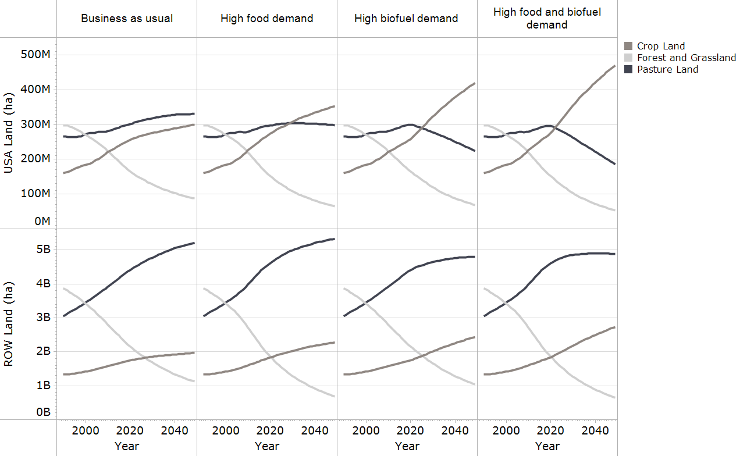

**Figure 3.** LUC for two regions across four commodity demand scenarios. In the BAU and high food demand scenarios, biofuel policies that are in place in as of 2012 are assumed to be met in 2019by food based crops.

**Table 4**. Percent change in land use from BAU scenario.

|  |  |  |  |  |  |  |
| --- | --- | --- | --- | --- | --- | --- |
| **Scenario** | **Region** | **Land Type** | **2020** | **2030** | **2040** | **2050** |
| HF | USA | Cropland | 7% | 12% | 16% | 18% |
| HF | ROW | Cropland | 5% | 9% | 13% | 16% |
| HF | World | Cropland | 5% | 10% | 14% | 16% |
| HF | USA | Pastureland | -1% | -5% | -8% | -10% |
| HF | ROW | Pastureland | 5% | 5% | 3% | 2% |
| HF | World | Pastureland | 4% | 4% | 2% | 1% |
| HF | USA | Forest and Grassland | -8% | -15% | -21% | -27% |
| HF | ROW | Forest and Grassland | -14% | -24% | -32% | -40% |
| HF | World | Forest and Grassland | -13% | -23% | -31% | -39% |
| HB | USA | Cropland | 1% | 17% | 31% | 40% |
| HB | ROW | Cropland | 0% | 8% | 17% | 24% |
| HB | World | Cropland | 0% | 9% | 19% | 26% |
| HB | USA | Pastureland | 0% | -13% | -24% | -32% |
| HB | ROW | Pastureland | 0% | -3% | -6% | -8% |
| HB | World | Pastureland | 0% | -3% | -7% | -9% |
| HB | USA | Forest and Grassland | 0% | -6% | -14% | -22% |
| HB | ROW | Forest and Grassland | 0% | -1% | -4% | -7% |
| HB | World | Forest and Grassland | 0% | -2% | -5% | -8% |
| HFB | USA | Cropland | 8% | 29% | 46% | 57% |
| HFB | ROW | Cropland | 5% | 18% | 30% | 39% |
| HFB | World | Cropland | 6% | 19% | 32% | 41% |
| HFB | USA | Pastureland | -2% | -18% | -32% | -44% |
| HFB | ROW | Pastureland | 4% | 2% | -3% | -6% |
| HFB | World | Pastureland | 4% | 1% | -5% | -9% |
| HFB | USA | Forest and Grassland | -8% | -20% | -30% | -39% |
| HFB | ROW | Forest and Grassland | -14% | -25% | -34% | -42% |
| HFB | World | Forest and Grassland | -13% | -24% | -33% | -42% |

Land use across all scenarios examined in this study is presented in figure 4. In the BAU scenario, projected cropland growth and patterns of land expansion are quite different in comparison to the other three scenarios. In the HF scenario, cropland expansion into pastureland leads to expansion into forest and grassland to meet demand for pasture. Because of increasing demands for meat, pastureland continues to grow globally in the HF case relative to the BAU case. Similarly, in the HB scenario, cropland is expanded by first converting pastureland and eventually converting available land, but the HB scenario requires much less expansion into available land to meet global cropland demand than the HF scenario because of the lower food requirements for meat. The combined impact of the HFB scenario requires substantial expansion into both pastureland and available land compared to the BAU case.

Even though pastureland increased slightly in the high food demand scenario, it decreased in the HF and HFB scenarios. These results highlight an underlying dynamic occurring, to some extent across all scenarios of the model. In some years, meat production could fall short, in particular for land-intensive commodities (e.g., beef). Demands for other commodities, such as cereals, are being met at most points in time in non-HFB scenarios. The exception is in the ROW HFB scenario between about 2010 and 2030, when the most rapid shifts are occurring in land use and commodities demanded. The rate of land conversion needed to meet increases in food and biofuel demands between 2010 and 2030 is so highest during this time period. During this time period there are unmet commodity demands (1-3% of total) occurring every few years as the model seeks to achieve equilibrium under highly stressful conditions. After this time period, non-meat demands were accommodated.

As described in the methods, the model is equilibrium-seeking, responding to demands for commodities. Consumption is constrained not to exceed physically and logistically feasible supply. Within a given region and time period, supply shortfalls of commodity crops lead to constraints in animal product consumption before constraining direct human consumption, so that if humans demanded both more grain and more meat, land would first be used to produce more grain. The model does not explicitly capture the potential substitution effects between animal and non-animal products with regard caloric intake. As prices for meat products go up people do not shift their diets towards alternative food commodities in addition to any demand reductions.

Supply shortfalls are more common in biofuel scenarios because biofuels’ use of land was given priority. Despite higher food demands in the HFB scenario, pastureland growth is much lower than that in the HF scenario, because land is first allocated for biofuel feedstocks. In practical terms, such shortfalls could be avoided through various means, such as by removing biofuel production requirements, structuring biofuel policies to respond to market conditions, switching diets to lower-land-use intensity meat use, or improving biofuel and food commodity. Section 5 of the SI gives an example future in which cellulosic biofuel yields improve or exacerbate shortfalls. An increase or decrease of 0.5% of annual average cellulosic feedstock yield growth from 2020-2050 had enough of an impact to free up or occupy substantial amounts of land. Specifically, in comparison to baseline assumptions and using Alexandratos and Bruinsma (2012), 0.4-0.5 billion people per year would, or would not, have wheat demands met, depending on this range of yield growth. While yield levels may not change underlying dynamics, they do have an important role to play in the magnitude of land used by biofuels and other human uses of land.

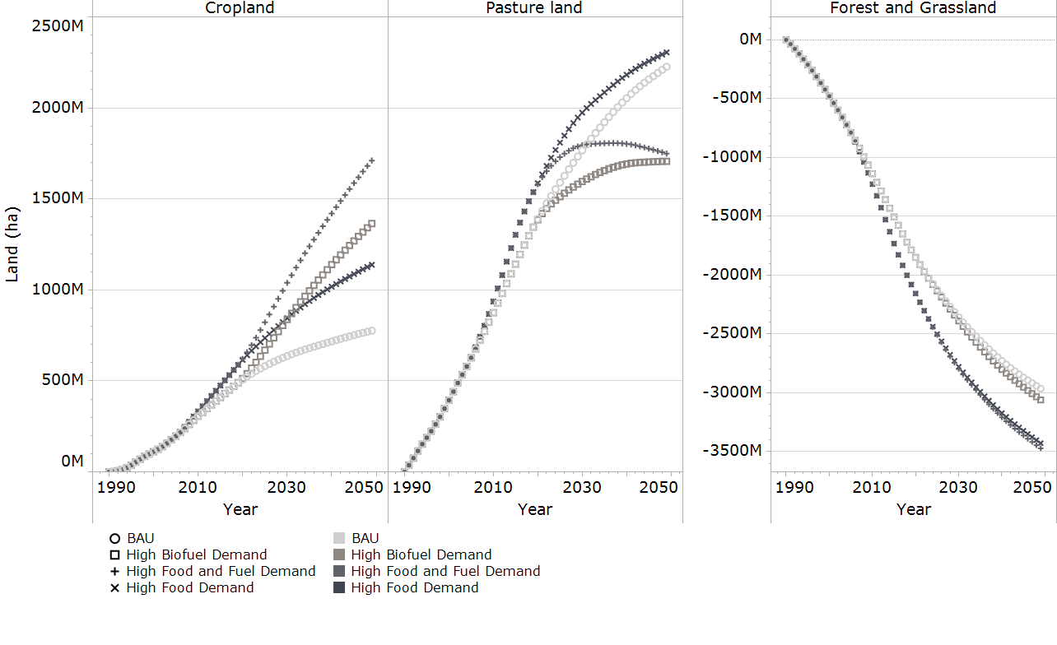

**Figure 4.** Global change from 1990 to 2050 in cropland, pastureland, and available land (i.e. forest and grassland), in response changes in demand.

BioLUC results are not predictions, but they may indicate when and why stresses arise in the global agricultural system. BioLUC is a simple model that focuses on bookkeeping for land stocks, food inventory, and international trade. It tends toward equilibrium conditions that allocate resources to meet demand. The model’s main use is to develop insights into the interplay among the myriad of factors impinging on the global land system. Therefore, we examined the dynamics of scenarios, rather than conducting detailed uncertainty analysis around any given scenario.

We have already outlined several limitations of our analysis, but one significant limitation is the resolution of our global regions. To address this, the flexible design of the BioLUC modeling framework allows for expansion and contraction of the number of regions as well as the use of alternative data sets (e.g., land cover) (see SI Section 6 for potential future work with BioLUC). Expanding to additional regions would allow us to improve model resolution and precision of the results, to better evaluate regional land use dynamics, and to compare BioLUC with other LUC modeling frameworks. For example, improving the model resolution should allow for correction of unrealistic land use-related traded disparities between the US and the ROW region that appear in our results. The two-region model does not capture complex inter-regional dynamics. That is, food and biofuel demands cannot be forcibly be met through imports at the expense of the internal demands of the export region, as might be expected in reality, due to different levels of purchasing power across regions. Modeling more regions would allow us to capture more trade complexity between developing and developed countries. For example, the general equilibrium modeling framework, GTAP, most recently aggregates its data sets to 19 regions for modeling of LUC.

We selected four scenarios to represent extreme biofuel and food consumption conditions, and evaluated them to examine a high-intensity agricultural future. Many other important scenarios are possible, including:

* Additional agricultural intensification that might occur in high demand situations. That is, higher prices could lead to investment in higher yielding crops and other intensification technologies, instead of the land expansion that we found herein.
* Alternative scenarios that explore the effects of cellulosic-based biofuel production on land that is less likely to compete with food crops, such as on the abandoned land category.
* Alternative meat consumption scenarios that free up pastureland. For example, can protein and biofuel demands be met at the same time through changes in dietary preferences?

1. **Conclusions**

BioLUC results are not predictions; the model only provides insights into the dynamic interactions of LUC drivers. Quantities and changes are provided to facilitate comparisons between various scenarios.

The HF and HB scenarios lead to differing levels of cropland expansion and unequal conversion levels of pastureland and available forest and grassland requirements. In our HB scenario by 2050 cropland has expanded by 25% relative to BAU. Cropland expansion occurs mostly at the expanse of pastureland (~500 million ha), but also some available forest and grassland to compensate for used pastureland or to be used as new cropland. In our HF scenario, a 15% overall increase in cropland relative to BAU occurred, but cropland expansion onto pastureland is low relative to the HB scenario (i.e., 100 million ha) in part due to meat demand and its higher land requirements relative to other commodities. Pastureland required directly for meat production and indirectly for conversion to cropland leads to greater expansion onto available forest and grassland in the HF scenario.

The differences in land use in the HF and HB scenarios have implications for the approximate used of land in the combined HFB scenario. In this scenario the increase in cropland of 40% relative to BAU is linked to biofuel and food demand in the BioLUC model, but based on the HB scenario most of that cropland expansion is needed for biofuels. However, based on our mode’s dynamics and speaking relative to our HB scenario there is a stronger link between food commodities, such as meat, and the conversion of forest and grassland. Based on the BioLUC model and the comparison of HF and HB scenarios, our results likely suggest that for the HFB scenario all else being equal by 2050 as compared to BAU:

* About 70% of cropland expansion is linked to higher biofuel demand
* 30% of cropland expansion is linked to higher food demand.
* The HFB scenario’s high pastureland requirements led to a greater expansion into available land that is likely more directly attributed to food than to fuel so roughly 25%-35% of expansion into forest and grassland seen in the HFB scenario is attributable to biofuels.

Our scenario analysis shows that, even under our limiting assumptions about the future, fairly aggressive future biofuel and food demands could mostly be met using a combination of agricultural and other available land. However, across all scenarios demands for the highest land-using meat commodity (e.g., beef) were difficult to meet given diet, population and other assumptions, particularly the assumption that non-meat demands (including biofuels) would be met first. Under the most extreme conditions in the HFB scenario there were some supply shortfalls relative to projected food commodity demand in the 2020-2030 timeframe. These supply shortfalls occurred when the rate of increase in food and biofuel demand was at its peak.

Our analysis is limited in several keys respects. We did not examine additional land intensifications or advanced biofuel systems using wastes and residues that would reduce land expansion requirements. These systems could mitigate the increases in cropland area, but are not expected to alter the underlying dynamics in the current version of the model, because these factors,e.g, land intensifications and using wastes and residues, could change the amount of land required but not the underlying dynamics of how land is used. One exception, which could change the underlying dynamics is to allow cellulosic fuel feedstocks to grow on the abandoned land category, which is not currently allowed in BioLUC

BioLUC and SD often include general simplifications, outlined in Table 1, primarily related to data and economic relationships, operating at relatively aggregated low-resolution level. Of particular importance is the lack of inter-regional dynamics in a two region system. Model simplifications prevent the study of key dynamics emerging from, or the direct result of, greater model detail. With the inclusion of additional regions ,trade dynamics in which greater LUC occurred in some areas over others could be explored, beyond the more proportional distribution seen in this analysis.

**Acknowledgements**

The authors wish to acknowledge the U.S. Department of Energy’s Office of Biomass Program which provided the funding for this work. The authors do not have any other potential conflicts of interest. Data sources used in the model are included in the supplemental information, and are cited in the references section.

Thank you to Dr. Robin Newmark, and Nate Blair of the Strategic Energy Analysis Center and Dr. Helena Chum of the National Bioenergy Center, and Research Fellow at the National Renewable Energy Laboratory, for providing internal review. Thanks to Kristen Johnson and Zia Haq in the U.S. Department of Energy’s Office of Biomass Program for their reviews and support of this project. Special thanks also to John Sheehan at the Institute on the Environment at the University of Minnesota for reviewing the paper, for helping us define the project scope, and providing feedback on earlier drafts, and to Dana Stright for helping prepare figures for this report.

Ethan Warner made major contributions to the writing process, and also made minor contributions to data processing and analysis. Dr. Daniel Inman also made major contributions to the writing process and was involved with data processing and analysis as well. Dr. Brian Bush made major data processing and analysis contributions and made minor contributions to the paper. Benjamin Kunstman made moderate contributions to both writing and data processing. Laura Vimmerstedt was a minor contributor to the writing and review process. Steve Peterson was responsible for BioLUC model development and construction, and also contributed in providing project scope and analysis. Jordan Macknick provided minor data processing and writing contributions. Dr. Yimin Zhang made minor writing contributions.

**References**

Ackerman F 2002 Still dead after all these years: Interpreting the failure of general equilibrium theory *Journal of Economic Methodology* **9** 119–39

Alexandratos N and Bruinsma J 2012 *World Agriculture towards 2030/2050: the 2012 revision* (Rome, Italy: Food and Agriculture Organization of the United Nations) ESA Working paper No. 12-03

Al-Riffai P, Dimaranan B and Laborde L 2010 *Global trade and environmental impact study of the EU biofuels mandate* (Washington, DC: International Food Policy Institute)

Bauen A, Chudziak C, Vad K and Watson P 2010 *A causal descriptive approach to modeling the GHG emissions associated with the indirect land use impacts of biofuels* (London, UK: E4Tech)

Berndes G, Bird N and Cowie A 2010 *Bioenergy, Land Use Change and Climate Change Mitigation* (IEA Bioenergy) Bioenergy:ExCo:2010:03

Bush B Inman D Macknick J Peterson S 2011 System Dynamic Approach to Model Land-Use Change from Biofuels. National Renewable Energy Laboratory Milestone Report: Golden CO

California Air Resources Board (CARB) 2009 *Proposed regulation to implement the low carbon fuel standard* (Sacramento, California: California Environmental Protection Agency Air Resources Board Stationary Source Division)

Chum H *et al* 2011 Bioenergy *IPCC Special Report on Renewable Energy Sources and Climate Change Mitigation* ed O Edenhofer *et al* (Cambridge, UK and New York, NY, USA: Cambridge University Press)

Dale V, Efroymson R and Kline K 2011 The land use–climate change–energy nexus *Landscape Ecology* **26** 755–73

European Commission 2009 *Directive 2009/28/EC of the European Parliament and of the Council of 23 April 2009 on the promotion of the use of energy from renewable sources* (Brussels, Belgium: European Commission)

FAO 2010 *FAOSTAT Agricultural Statistics* (Rome, Italy: Food and Agriculture Organization of the United Nations)

Fargione J Hill J Tilman D Polasky S and Hawthorne P 2008 Land Clearing and the Biofuel Carbon Debt. *Science* 319(5867) 1235-1238

Farrell AE Plevin RJ Turner BT Jones AD O'Hare M and Kammen DM 2006 Ethanol Can Contribute to Energy and Environmental Goals. *Science* 311(5760) 506-508

Fritsche U Hennenberg K Hünecke K 2010 The “iLUC factor” as a Means to Hedge Risks of GHG Emissions from Indirect Land Use Change (Darmstadt, Germany: Oeko Institute)

Forrester J W 2007 System dynamics: the next fifty years *System Dynamics Review* **23** 359–70

Ghaffarzadegan N, Lyneis J and Richardson G P 2011 How small system dynamics models can help the public policy process *System Dynamics Review* **27** 22–44

Hiederer R, Ramos F, Capitani C, Koeble R, Blujdea V, Gomez O, Mulligan D and Marelli L 2010 *Biofuels: A New Methodology to Estimate GHG Emissions from Global Land Use Change - A methodology involving spatial allocation of agricultural land demand and estimation of CO2 and N2O emissions* (Ispra, Italy: European Commission - Joint Research Centre)

ICF International 2009 *Life cycle greenhouse gas emissions due to increased biofuel production model linkage peer review report* (Washington, DC: Environmental Protection Agency)

IPCC 1996 Working Group II: Impacts, Adaptation, and Mitigation of Climate Change: Scientific-Technical Analysis *Second Assessment Report of the Intergovernmental Panel on Climate Change: Climate Change 1995* ed R T Watson, M C Zinyowera and R H Moss (Cambridge, UK: Cambridge University Press)

Kim H Kim S Dale BE 2009 Biofuels, land use change, and greenhouse gas emissions: Some unexplored variables *Environmental Science & Technology* 43, 961

Lywood W 2008 *Indirect effects of biofuels* London: Renewable Fuels Agency

National Renewable Energy Laboratory 2012 BioLUC Model National Renewable Energy Laboratory: Golden CO

Panichelli L and Gnansounou E 2008 Estimating greenhouse gas emissions from indirect land-use change in biofuels production: concepts and exploratory analysis for soybean-based biodiesel *Journal of Scientific & Industrial Research* **67** 1017–30

Pelletier N 2008 Environmental performance in the US broiler poultry sector: Life cycle energy use and greenhouse gas, ozone depleting, acidifying and eutrophying emissions. *Agricultual Systems* *98*(61-73)

Pelletier N Lammers P Stender D Pirog R 2010 Life cycle assessment of high- and low-profitability commodity and deep-bedded niche swine production systems in the Upper Midwestern United States. *Agricultual Systems* **103**(93): 599-608

Pelletier N Pirog R Rasmussen R 2009 Comparative life cycle environmental impacts of three beef production strategies in the Upper Midwestern United States. *Agricultural Systems* 103: 380-389

Plevin R J Michael O H Jones A D Torn M S and Gibbs H K 2010 Greenhouse gas emissions from biofuels' indirect land use change are uncertain but may be much greater than previously estimated *Environmental Science & Technology* **44** 8015–21

Rotz CA and Zartman DL 1997 *Performance and Economics of a Perennial Cow Dairy Farm* (US Dairy Forage Research Center, Univ. WI)

Searchinger T, Heimlich R, Houghton R A, Dong F, Elobeid A, Fabiosa J, Tokgoz S, Hayes D and Yu T H 2008 Use of U.S. croplands for biofuels increases greenhouse gases through emissions from land-use change *Science* **319** 1238–40

Sheehan J 2009 Sustainable biofuels: A commonsense perspective on California’s approach to biofuels & global land use *Industrial Biotechnology* ***5****(2): 93-103*

Sheehan J 2012 *Reflections on the failure of models to address the land use impacts of biofuels* (Saint Paul, Minnesota: University of Minnesota Institute on the Environment)

Southgate D, Graham D H and Tweeten L 2007 *The World Food Economy* 1st ed (Malden, Massachusetts: Blackwell)

Tilman D Balzer C Hill J and Befort BL 2011 Global food demand and the sustainable intensification of agriculture. *Proceedings of the National Academy of Sciences*.

Tipper R Hutchison C and Brander M 2009 *A practical approach for policies to address GHG emissions from indirect land use change associated with biofuels* Edinburgh: Ecometrica

Tyner W, Taheripour F, Zhuang Q, Birur D and Baldos U 2010 *Land use changes and consequent CO2 emissions due to U.S. corn ethanol production: A comprehensive analysis* (West Lafayette, Indiana: Purdue University - Department of Agricultural Economics)

UK Department for Transport 2012 *Biofuels and Sustainability* Web page (London, UK: Department for Transport) <http://www.dft.gov.uk/topics/sustainable/biofuels/sustainability/>

US Environmental Protection Agency 2010 *Renewable Fuel Standard Program (RFS2) regulatory impact analysis* (Washington, DC: U.S. Environmental Protection Agency)

Wise M, Calvin K, Thomson A, Clarke L, Bond-Lamberty B, Sands R, Smith S J, Janetos A and Edmonds J 2009 Implications of limiting CO2 concentrations for land use and energy *Science* **324** 1183–86

1.
2. Authors are willing to provide a copy of model internal equations or the milestone report as requested. Official public release of the model will not be complete until 2013.